Modeling Entamoeba hystolytica glycolysis points out that glucose uptake is the rate limiting step, but a drug cocktail is necessary for medication.

## Author of protocol: Ábel Vértesy,

## Major Systems Biology;

## Master Program Molecular Biosciences;

## University of Heidelberg;

## Supervision: Prof. Dr. Ursula Kummer;

## Modeling of Biological Processes;

## University of Heidelberg

Table of Contents

1. Abstract 3

2. Introduction 3

3. Methods 4

Statistical analysis 4

4. Results 5

Uncertainty analysis over normal prior 6

Uncertainty analysis over uniform prior 6

Uncertainty about the kinetics of the glucose transporter 8

Uncertainty about the structure of glycolysis 8

Model boundaries and model selection 9

5. Discussion 9

6. Appendix 10

7. References 10

# Abstract

An extended model of Entamoeba hystolytica glycolysis is presented, which is applied for drug target prediction. Glucose transporter (GLUT) and hexokinase (HK) exerts the strongest control on glycolytic flux, therefore are the prime candidates. This study also pinpoints the use of uncertainty analysis, a statistical approach towards parameters. This uncovers that a heterogeneous population may react much less to singular drug treatment, and shows that a 2-component drug-cocktail is necessary and also sufficient for effective treatment. The Entamoeba glycolysis appears to have a single rate limiting step, which can shift from GLUT to HK with subtle parameter changes. This shift occurs if the quotient of the VGLUT of the import process and the Vmax of the HK is higher than a certain threshold that depends on other parameters. Since the GLUT kinetic parameters are unknown, these measurements are decisive for medical research. Hexokinase Km values also depend Altogether, the GLUT is the key candidate being the rate limiting enzyme over a wide range of the parameters, and having only a 32% sequence similarity to the closest human protein, the “transmembrane protein 144” of unknown function. This study also examples how careful the modeler should be with the boundaries of the model, and that aiming for smaller but better described models is not always the right choice.

# Introduction

Amoebiasis, caused mainly by Entamoeba hystolytica is one of the major tropic health concerns, leading to an annual 70.000 deaths [1], however as rare in most developed countries less effort is put into concerning medical research. As Entamoeba trophozoites only produce ATP by glycolysis, its energy metabolism appears an ideal target for medical intervention. The Entamoeba glycolytic pathway is not fully discovered, the ways of glucose uptake, the presence and role of alternative enzymes is not clear, also the Entamoeba specific Pentose-Phosphate Pathway (PPP) –with many junctions to glycolysis- is mostly undiscovered, but known to be very different to the general scheme. [2]

On the other hand, the basic wiring of glycolysis is very well known, and due to former research [3–5] on the pathway, most parameters are measured in vitro. An upstream-extended model is presented, which incorporates glucose uptake. [6,7] This model also simplifies a number of details that appeared to be indifferent for the predictions in the earlier study. This model showed that glucose uptake is by far the most important controller of glycolysis. This conclusion is new from the previous model [4], but suggested by some early biochemical works [6,7] and also a known phenomenon in other organisms. [8,9]

One model existed on the system, which was well supplied by kinetic data, however had numerous drawbacks. Prior work has neglected glucose import, the first step of the pathway, which is largely unknown, but shown to be the rate limiting step in vitro. [6,7] Entamoeba has two parallel branches in the pathway, containing both ATP/ADP-dependent phospho-fructo-kinase [10] and pyruvate-kinase [11] and their PP-dependent counterpart [10] [12]. The utilization of PP as energy currency is common in anaerobic parasites, but it is rare that organism own both alternative set of 2-2 enzymes. Saavedra et al. did not include the alternative pathways since they showed low activity in vitro, although the same group discovered presence of ATP-dependent PK in [11]. Later genomic analysis predicted further two pyruvate kinases[1]. Also, this earlier work simply set PP to a constant level, making it independent from the system. Fixing the alternative energy currency in a model of energy metabolism is peculiar. Also the argumentation that PP has to be constant, since otherwise the model does not describe the data sounds not well founded.

To provide results closer to in vivo diversity, the effect of smaller and larger parameter deviations has to be statistically analyzed to represent biological heterogeneity. Due to the extensive modeling and experimental work on the system, most of the kinetic parameters are known; this delivers a very small degree of freedom in regards to parameters. However regarding deviation of parameters is also a necessity, since the data comes from in vitro enzyme kinetic experiments that may differ even by magnitudes from in vivo values. The aim of this paper is also to clearly show, how robust predictions are in of such heterogeneity and uncertainty. Likewise, one argument that modelers often face, is that since nonlinear dynamical systems (complex models) are capable of many different output and these may strongly depend on parameters, therefore model-predictions based on unreliable data are only hypothetical and less useful. This is certainly the case if one thinks of bifurcations; but strong parameter dependence is no general rule. Information is stored in topology (network structure) and in dynamics (kinetic laws) just as in the hardly determined parameters. These sources of information are combined in a model and lead to predictions. Now these predictions depend non-trivially and very diversely on the different kinds of data or information. In the presented case, the predictions dependence on parameters is clearly defined.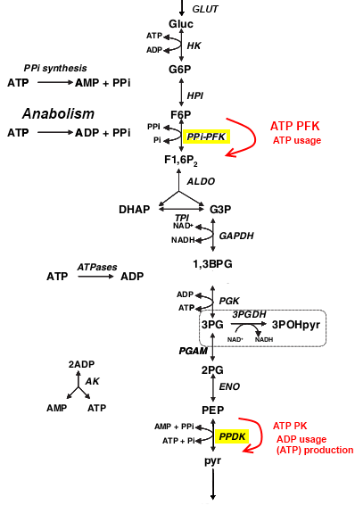

Figure Pathway scheme. Red arrovs show the two parallel branches. Soucre: Saavedra 2007, modified

# Methods

A kinetic model of Entamoeba hystolytica glycolysis is created, based on pathway information on KeGG database, literature knowledge on Entamoeba specific enzymes and an existing model of the system. Copasi 4.5.3 [13] was used for modeling and analysis, and R 2.14 for final statistics and visualization.

The model scheme follows a linear path with some branches. The downstream parts of the system were shown not to control flux neither in our, nor in the prior study[2]. [4] Also, these reactions do not contribute to ATP or Pyrophosphate (PP) generation. Finding this, they were neglected to reduce unnecessary complexity.

There are interesting features of the Entamoeba glycolysis, first the usage of an alternative energy currency. It is known that PP is generated as a side product of different anabolic reactions, e.g. the biosynthesis of proteins, lipids and phospholipids, nucleotides, nucleic acids, urea, steroids, structural polysaccharides and glycogen. [14] Due to this diversity, and since it is not known, what percent of used ATP-s is yield PP, therefore ATP was consumed in different ways yielding ADP, AMP and PP in different combinations. These simple reactions stand in general for all energy consuming reactions of the cell.

Flux control coefficients are used to identify ideal drug-target candidates. This is a widely used abstract property of an enzyme, that describes how the flow through enzyme B change if one change the flux through enzyme A. This tells us about the efficacy of a hypothetic drug: how does the whole glycolytic throughput change, if one regulate down enzyme A? Scaled coefficients are presented, it means that their values are normalized by the corresponding steady state fluxes.

## Statistical analysis

Knowing that kinetic parameters may differ from what measured, we asked how this variance affects the glucose transporter, or precisely how are the scaled flux control coefficients of the candidate enzymes change? Monte Carlo simulations show a distribution of the flux control coefficients; this in turn leads to a more complex general conclusion. In the simulation, a certain distribution of parameters is assumed; from that random parameters are taken many times (10K), and the flux control coefficients are calculated each time. The incorporation of a prior distribution distinguishes this method from parameter scans, another widely used tool. Again the role of each enzyme depends on topology, kinetics and parameters. The choice of prior distribution to sample from largely affects the outcome. It has to be chosen so, that it contains minimal assumptions but uses the known information maximally. One can argue that he knows the most likely mean value, than the proper choice is a normal distribution, but if one is skeptical about the estimated parameters, or say that the data only provides information about the magnitude, the proper choice is a uniform distribution [15,16] Since it is somewhat subjective how to consider the dataset, we proven our results with both distributions.

# Results

The model was fitted to experimentally measured steady-state metabolite concentrations with a summed square difference of 3.6*10-3. In this setup most parameters were optimized in a range of 3 magnitudes around in vitro measurements. As it is a generally hold view that Km values are much more accurately measured than Vmax values. Since even in Km values there were magnitude differences [3], in a second scenario the Vmax values are neglected and only Km data are used. The model was fitted allowing +/-50% of the measured Km values, others were kept among physiological values. The model described the data very well, with a summed square difference of 5.87*10-3 and glucose import exerting the highest flux control.

Model was fitted many times starting form randomized parameter values. The models reproduced the data with rather large variance in estimated parameters (+/-1 magnitude), this mark of unidentifiability is not surprising when all parameters were let some freedom. The first optimal-fit model was chosen, it uses parameters that generally does not differ more than 1 magnitude from the measured values.

Our optimum fit model suggests the glucose transporter as the key drug target, showing approximately a 100 times stronger control on the flux than hexokinase. As its absolute and relative control is high, one can say this is an effective target. Nevertheless for drug targets another important property is specificity that the drug should not knock down the host’s glycolysis. Comparison of the sequences showed that glucose transporter has a very low similarity to any human enzymes, with about 36% sequence similarity to the closest human enzyme of unknown function. Such difference eases a design of a selective drug, suggesting it as an ideal candidate for further research.

Nevertheless one should not make a drug against a system at its optimum. Conditions will necessarily wobble out of optimum due to extrinsic noise. It can be interpreted as the parameters of the model will necessarily be different in part of the cells. A drug has to be efficient in all these cells, even far away from the optimum state. To deal with it, methods as the uncertainty analysis can be applied to tell how likely is it that the drug against the population of cells, if each cells’ parameters randomly differ from the optimum ones. Uncertainty analysis showed that even a perfect drug against Glucose transporter would have very limited effect, as in approximately 25% of the disperse parameters; the targeted enzyme just looses flux control to the hexokinase.

## Uncertainty analysis over normal prior

Assuming our estimated parameters as true estimate of the real parameter values, 100.000 parameters were randomly sampled sets from a normal distribution with 10% absolute variance for each parameter. Small changes in parameters usually result in slightly different steady states, which expected to, but not necessarily represent biological conditions. Still, likely that most of the solutions stand for different in vivo conditions. The model reached a steady state in 81381 parameter sets.

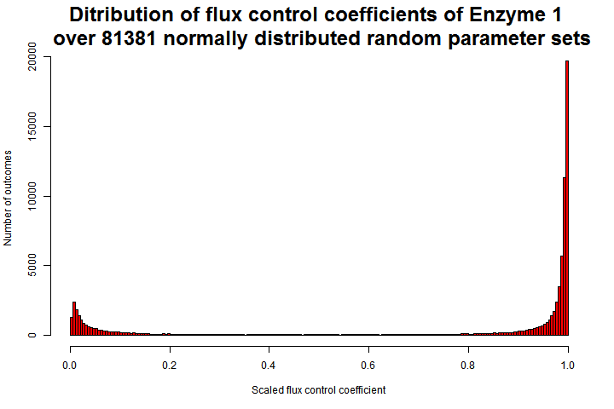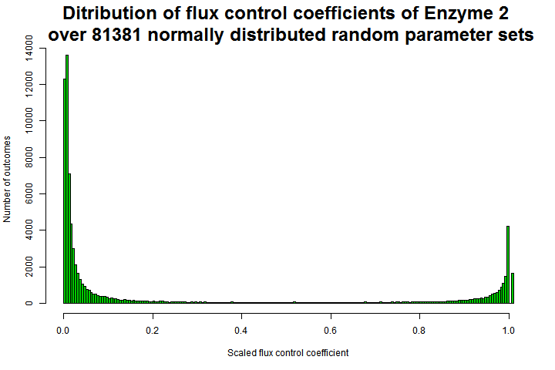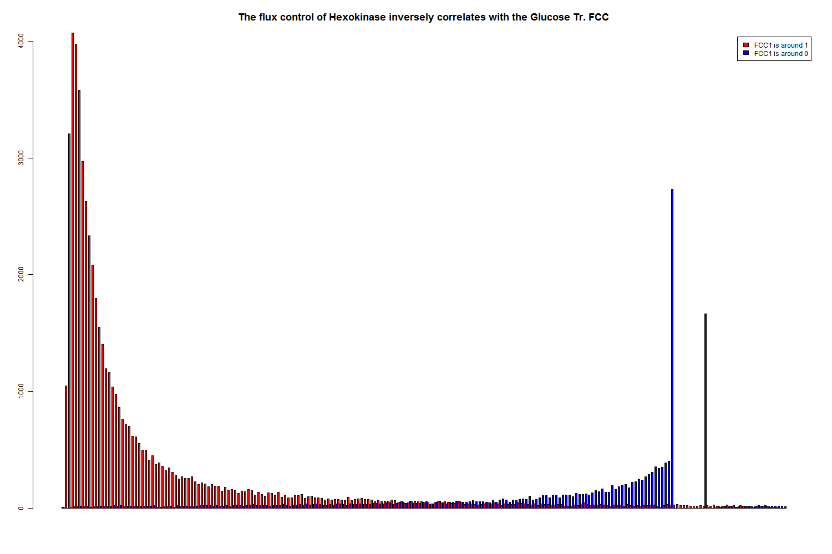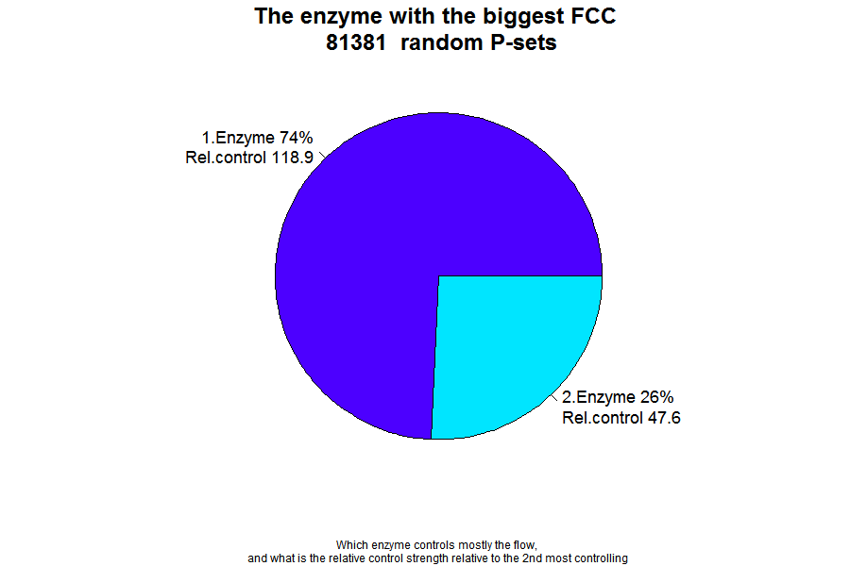

Figure : In the first scenario, accepting parameters estimates as true predictions, in most cases the glucose transporter governs the flux (A, enzyme 1), however in a part of the cases the Hexokinase (B, enzyme 2) rules the pace. Panel (C) shows that these cases are complementary; it is the same dataset as in (B) filtered for very low (blue) and very high (red) values in (A). (D) shows that in one fourth of the parameter sets are the hexokinase taking the flux control, which is a new finding to the optimum-fit solution.

As stated above the model uses parameters quite different from measured ones, therefore a more realistic approach -under the assumption of bad quality data- is to sample parameters uniformly from a larger range, without assuming a most likely mean value. We were interested in the distribution of flux control among the most controlling enzymes, and found that the simple rate limiting characterizes this system, as the most controlling enzyme has generally 47-118x higher FCC than the 2nd most controlling, meaning generally one single step controls the flux.

## Uncertainty analysis over uniform prior

Assuming that measurements tell the approximate order of magnitude of parameters 10.000 parameters were randomly sampled sets from a uniform distribution over a range of 3 magnitudes.

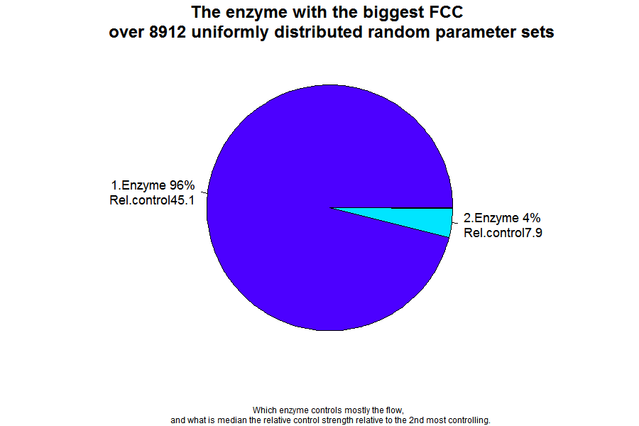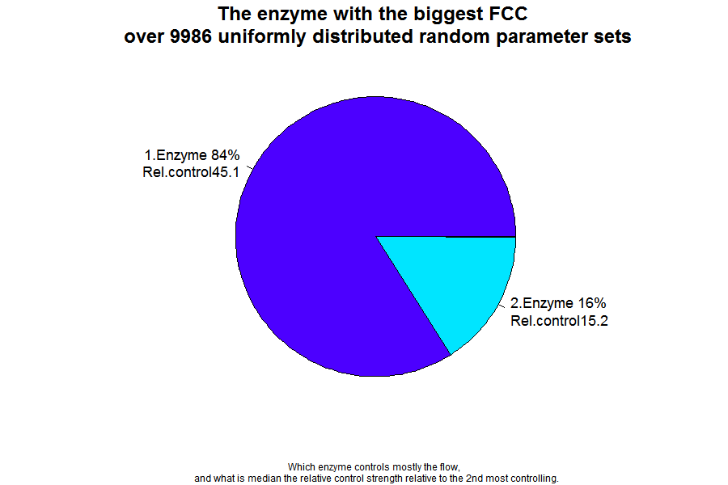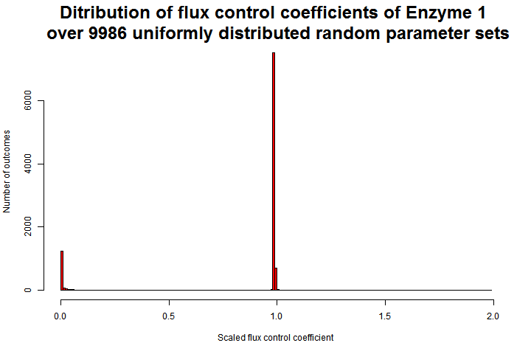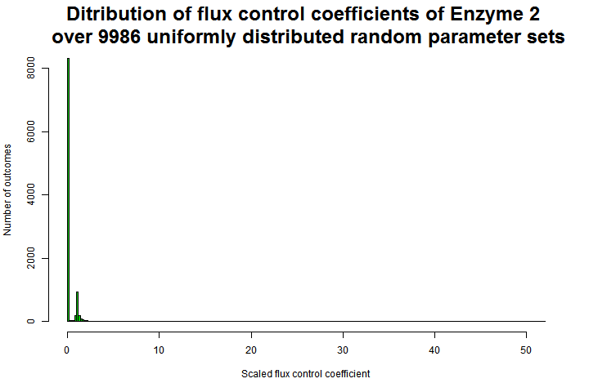 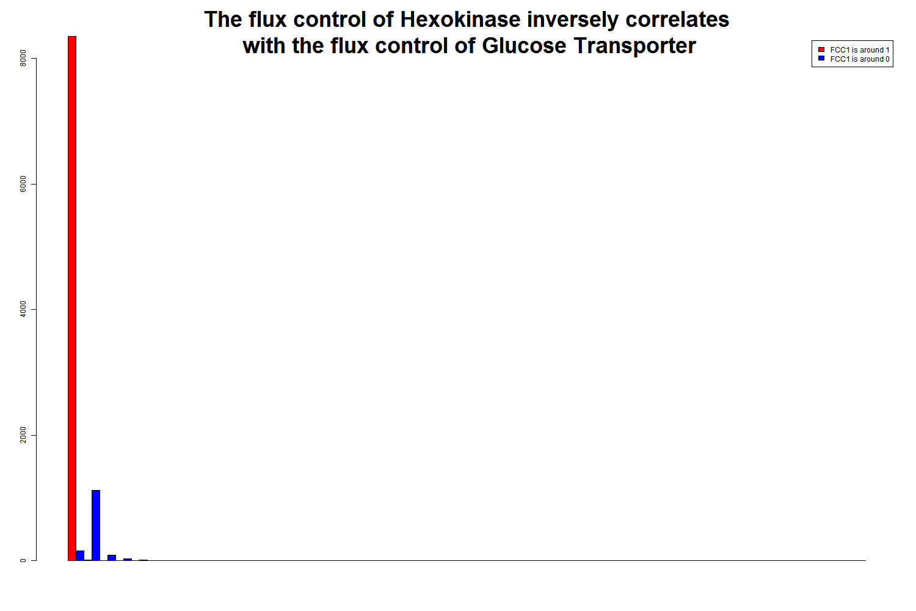

Figure : Flux control coefficient in steady states at random parameter sets sampled from a uniform distribution of 3 magnitudes (A-D) and from 5 magnitudes (E) showed an increased role of glucose transport, also giving a hint on that parameters leading to the hexokinase control lay in smaller interval.

Sampling from a wider range, assuming less reliable information on parameters showed a more robust role of the glucose transporter. From an extended the range 10.000 random parameter sets were sampled from a uniform distribution over a range of 5 magnitudes, from that 8912 resulted in a Steady State. These simulations lead to an even bigger proportion of glucose transporter control. However these steady states may be quite far from biological conditions therefore should be handled with caution.

Then, random sampling was restricted for single reactions and found that only the glucose transporter and the hexokinase parameters account for the shift in flux control. Changes in other reaction parameters never led to a state where hexokinase governs the flux control.

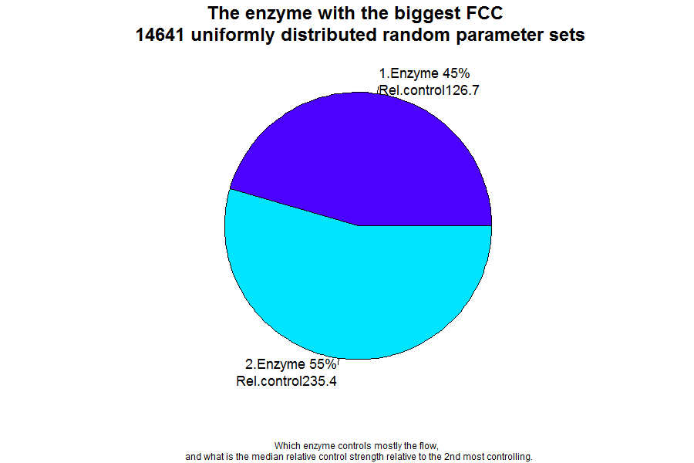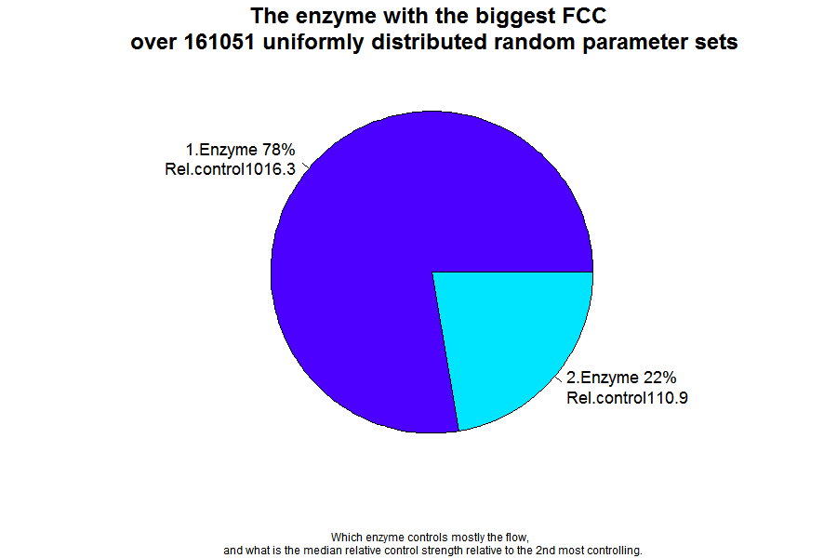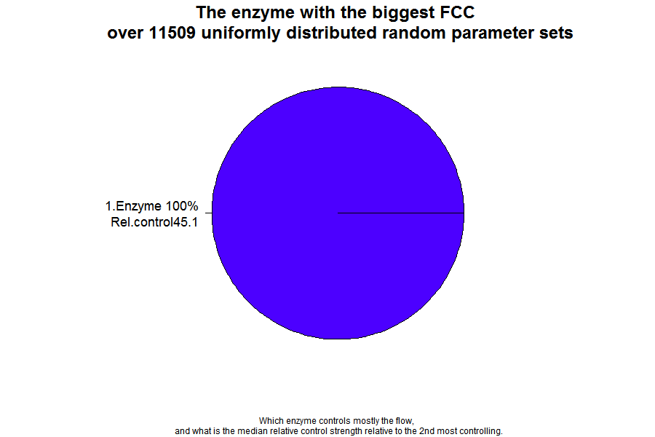

Figure Randomly sampled parameters from a uniform distribution of 3 magnitudes for the 1st 2nd and all other (3rd -19th) reactions resulted in a shift in Flux control in 55%, 22% and 0% of the cases.

It seems from the first chart, that most changes in the parameters let hexokinase govern the flux. Although, the uniform distribution is symmetric, only the results of the parameter sets are presented that lead to a steady state, and thus can be biased. Small fluxes may lead to a (potentially zero-flux-) steady state, whereas very big parameter values may not lead to steady state at all, therefore not represented in the chart. This applies to the other charts too. Parameter changes of all other reactions lead to no change in flux control, as exemplified in chart C. The conclusion from this analysis that the balance between HK- and GLUT- control depend more on GLUT parameters, and less on HK parameters.

In further, a parameter scan is performed to show which exact parameter thresholds distinguish the two control scenarios. Thresholds for GLUT- Vmax, HK-Vf, and for both substrates HK-Km are found, however the exact values depend on other parameters, therefore only become meaningful if these are measured accurately.

Table : The flux control shifts, when quotient of the GLUT-vmax and HK-Vmax-forward is between a certain range (0.725-0.686).

|  |  |  |  |  |
| --- | --- | --- | --- | --- |
| **Vmax relation** | **GLUT FCC < 0.1** | | **GLUT FCC > 0.95** | |
|  | 0.181 | 0.1536 | 0.172 | 0.1536 |
|  | 24.9568 | 21.2 | 24.9568 | 22.4 |
| **Quotient*100** | **0.725** | **0.725** | **0.689** | **0.686** | **(mmol/l)^2** |

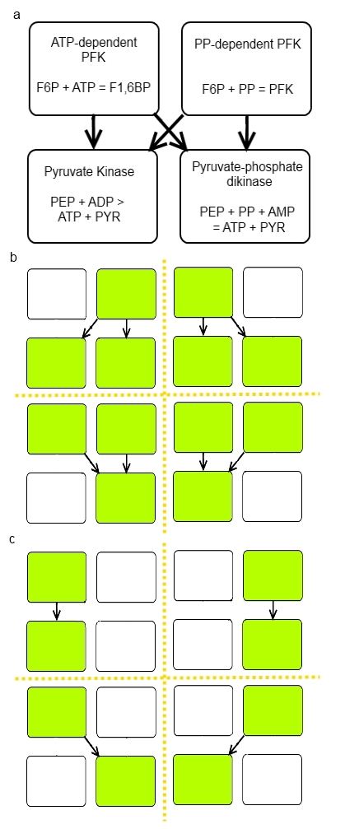However we found an interesting relation. The glucose transporter is the rate limiting step as long as the Vmax of the glucose import is lower than 0.689% of the Hexokinase (forward) Vmax. If the GLUT fwd Vmax is higher than 0.725%, then the flux control is fully shifted to the Hexokinase. Which of these two parameters is varied is indifferent. The Km values of hexokinase for its substrates also affect flux control, but such obvious relation is not found among them.

## Uncertainty about the kinetics of the glucose transporter

Since the biochemistry of the glucose transporter is largely unknown, we asked whether it will be still the optimal candidate if it would follow a different kinetic. A simple model selection showed, that a reversible Michaelis-Menten is the simplest kinetic that can describe the observed data. Replacing the kinetic with a reversible mass action kinetic provided only equilibrium (zero flux) steady states in all 10 rounds of parameter estimation over 4 magnitudes for all parameters, meaning that this kinetic is insufficient to describe the glucose transport in Entamoeba with any parameter set. Irreversible mass action kinetic was also unable to describe the observed values with a realistic steady state.

One should ask whether multiple processes contribute the glucose uptake, but no data supports this idea. In other, non-parasitic amoebae the usual way of glucose uptake is pinocytosis; however this could not account for the fast sugar import of Entamoeba hystolytica. [12] In other organisms, ways of active glucose transport is known, but since one molecule of glucose yields only 3 ATP-s (as both models predict, that only the PPi-PFK used), it may be worthwhile only in energy rich cases by an additional mechanism. Active import processes are neither favored by experimental measurements. [6] The transporter follows equilibrium kinetics, no common inhibitors were found with erythrocyte glucose transporters, thus its structure and/or mechanism appears to be very different. [7] Concluding, the presences of multiple glucose transporters were suggested, but later genomic work identified a single glucose transporter similar to prokaryotic type ribose-porters. [17] A BLAST on its amino-acid sequence resulted in 36% sequence similarity to the closest proven human protein (Transmembrane protein 144). There is approximately 40 % sequence similarity to various predicted or uncharacterized proteins.

Figure : The Alternative pathways allow 8 different structural variants, missing 1 or 2 enzymes (white boxes)

## Uncertainty about the structure of glycolysis

Entamoeba owns multiple enzymes parallel enzymes, but their role is not experimentally clarified. Therefore multiple parameter estimations were performed, with 8 model derivatives that missed one or two reactions as in Figure 5. Each model was fitted 10 times over a parameter range of 5 orders, but only one structurally simplified variant was able to fit the data well, which missed the ATP-dependent phospho-fructo kinase. This enzyme was also expected to be unnecessary, as the steady state flux thorough this enzyme was always zero in optimal fits of the master model and most other model variants. Still, pyruvate kinase is necessary for the description of the system with a model treats pyrophosphate.

## Model boundaries and model selection

Our result also points out how decisive can be the selection of model boundaries. Including a single reaction led to completely different predictions. Such implications are known from before [18][9]. Therefore we argue that prioritizing simple but well described models over more complex, but less defined models is not always a successful principle. The principle that underlies the preference for simpler models, is that models with higher number of unknown parameters has a higher probability of over-fitting, and the predictions are more depending on assumptions on the unknown. While this is well founded and widely applied principle, we argue that considering information only about parameters and ignoring information about structure and dynamics leads to a biased choice of model in some cases.

In our view, the uncertainty is about the system; this is not a property of the model. In a simple model this uncertainty can be excluded from the model, on the price of losing predictions, or predicting false. In this case excluding glucose transport leads to a well described model that describes the data very well. However, this model trivially cannot make statements about the glucose transporter.

Our extended model brings four unknown parameters, but uses the information that there is an enzyme feeding glycolysis with defined connections and equilibrium kinetics. In this case the structure and the dynamics carry adequate information, leaving weak and definable dependence on parameters.

# Discussion

The conclusions of the above study are threefold. First a drug-target candidate is proposed, that was ignored in latest research. Our finding is though not new – rather a modeling reinforcement of an early finding. [7]

Secondly this study showed that a careful selection what is included in the model should be more careful than it is often done. The exclusion of partly unknown components lead to a better defined model, but in turn the model may lose some of the most important conclusions.

A third conclusion is that one should not consider predictions of single models relying on a single optimal parameter set. Approaching parameters as dispersed values lead to more robust and quite different conclusions in this case, namely the necessity of a drug cocktail in medication. As there was also some uncertainty in the architecture of the pathway, not only parameter variants were considered, but also kinetic and structural variants. These showed the necessity of Michaelis-Menten kinetics and that the phospho-fructo-kinase is not necessary to describe data, but all other enzymes are required.

We showed that Entamoeba glycolysis is controlled by a single rate limiting step. Statistical analysis showed that depending on specific parameter relations the flux control rapidly swifts from GLUT to HK, leaving a very narrow range when they share the flux control on the system. GLUT is clearly the optimal drug-target candidate, because of its overwhelming flux control at optimum conditions and because it keeps this role in the majority random parameter conditions. It is a valuable candidate also because there are no isozymes or other genes in the annotated Entamoeba genome that are related to glucose import. Finally because this protein is only 36% identical to the closest human protein.

There is always some uncertainty about biological systems, which is reflected in the models. Even if one would have a model that is completely surely the only right model of the system, with all parameters measured in vivo, it is not wise to decide for drug targets only analyzing a system-property at a single optimum condition. Robust drug candidate selection has to be robust towards any deviation of parameters that the parasite may undergo in the host.

This study was also nice example how delicate is the choice of boundaries for a model. Even a slight extension of a model can lead to very different conclusions. Even if this seems an obvious extension, it was overlooked before in the case for yeast flux control analysis in [18] and [9].

# Appendix

The Appendix is accessible online: <http://vertesy.web.elte.hu/Entamoeba/>

###### Appendix.xls

###### The glucose transporter

The annotated Entamoeba genome[3] contains only one gene for glucose transporter which has a 100% sequence identity to a purified and sequenced enzyme with unknown function[4]. See further details in Supplementary table. This enzyme has only 36% sequence identity to the closes human protein, “Transmembrane protein 144” and there are no vertebrate enzymes that are more then 37% similar in sequence.

###### Model files

1. Optimal fit model
2. Model with Km values close to measurements

###### Archive of output images

# References

1. WHO (1998) World Health Report: Life in the 21st century - A vision for all.

2. Barrett MP (1997) The pentose phosphate pathway and parasitic protozoa. Parasitology today 13: 11–16. Available:http://www.ncbi.nlm.nih.gov/pubmed/15275160.

3. Saavedra E, Encalada R, Pineda E, Jasso-Chávez R, Moreno-Sánchez R (2005) Glycolysis in Entamoeba histolytica. Biochemical characterization of recombinant glycolytic enzymes and flux control analysis. The FEBS journal 272: 1767–1783. Available:http://www.ncbi.nlm.nih.gov/pubmed/15794763. Accessed 2 September 2011.

4. Saavedra E, Marín-Hernández A, Encalada R, Olivos A, Mendoza-Hernández G, et al. (2007) Kinetic modeling can describe in vivo glycolysis in Entamoeba histolytica. The FEBS journal 274: 4922–4940. Available:http://www.ncbi.nlm.nih.gov/pubmed/17824961. Accessed 3 July 2011.

5. Moreno-Sánchez R, Encalada R, Marín-Hernández A, Saavedra E (2008) Experimental validation of metabolic pathway modeling. The FEBS journal 275: 3454–3469. Available:http://www.ncbi.nlm.nih.gov/pubmed/18510554. Accessed 26 August 2011.

6. Serrano R, Reeves RE (1974) Glucose transport in Entamoeba histolytica. The Biochemical journal 144: 43–48. Available:http://www.pubmedcentral.nih.gov/articlerender.fcgi?artid=1168462&tool=pmcentrez&rendertype=abstract.

7. Serrano R, Reeves RE (1975) Physiological significance of glucose transport in Entamoeba histolytica. Experimental parasitology 37: 411–416. Available:http://www.ncbi.nlm.nih.gov/pubmed/165094.

8. Bakker BM, Walsh MC, ter Kuile BH, Mensonides FI, Michels P a, et al. (1999) Contribution of glucose transport to the control of the glycolytic flux in Trypanosoma brucei. Proceedings of the National Academy of Sciences of the United States of America 96: 10098–10103. Available:http://www.pubmedcentral.nih.gov/articlerender.fcgi?artid=17848&tool=pmcentrez&rendertype=abstract.

9. Elbing K, Larsson C, Bill RM, Albers E, Snoep JL, et al. (2004) Role of Hexose Transport in Control of Glycolytic Flux in Saccharomyces cerevisiae Role of Hexose Transport in Control of Glycolytic Flux in Saccharomyces cerevisiae. Society. doi:10.1128/AEM.70.9.5323.

10. Chi a S, Deng Z, Albach R a, Kemp RG (2001) The two phosphofructokinase gene products of Entamoeba histolytica. The Journal of biological chemistry 276: 19974–19981. Available:http://www.ncbi.nlm.nih.gov/pubmed/11262402. Accessed 3 November 2011.

11. SAAVEDRA E, OLIVOS A, ENCALADA R, MORENO-SANCHEZ R (2004) Entamoeba histolytica: kinetic and molecular evidence of a previously unidentified pyruvate kinase. Experimental parasitology 106: 11–21. Available:http://cat.inist.fr/?aModele=afficheN&cpsidt=15580345. Accessed 6 December 2011.

12. Reeves R (1968) A new enzyme with the glycolytic function of pyruvate kinase. Journal of Biological Chemistry 243: 3202. Available:http://www.jbc.org/content/243/11/3202.short. Accessed 17 February 2012.

13. Hoops S, Sahle S, Gauges R, Lee C, Pahle J, et al. (2006) COPASI--a COmplex PAthway SImulator. Bioinformatics (Oxford, England) 22: 3067–3074. Available:http://www.ncbi.nlm.nih.gov/pubmed/17032683. Accessed 10 June 2011.

14. Russell R (1976) Metabolism of inorganic pyrophosphate (PPi). Arthritis &amp; Rheumatism. Available:http://onlinelibrary.wiley.com/doi/10.1002/1529-0131(197605/06)19:3+%3C465::AID-ART1780190722%3E3.0.CO;2-%23/abstract. Accessed 20 February 2012.

15. Jaynes E (1957) Information theory and statistical mechanics. Physical Review: 620–630. Available:http://exordio.qfb.umich.mx/archivos PDF de trabajo UMSNH/Aphilosofia/bayesian importantes/theory.1 muy bueno.pdf. Accessed 13 January 2012.

16. Klipp E, Liebermeister W, Wierling C, Kowald A, Lehrach H (2009) Systems biology: a textbook. Vch Pub. p.

17. Loftus B, Anderson I, Davies R, Alsmark UCM, Samuelson J, et al. (2005) The genome of the protist parasite Entamoeba histolytica. Nature 433: 865–868. Available:http://www.ncbi.nlm.nih.gov/pubmed/15729342.

18. Pritchard L, Kell DB (2002) Schemes of flux control in a model of Saccharomyces cerevisiae glycolysis. European Journal of Biochemistry 269: 3894–3904. Available:http://dx.doi.org/10.1046/j.1432-1033.2002.03055.x.

1. Temporary IDs: 345.m00060; 77.m00146 and 503.m00035. <http://old.genedb.org/>
2. FCC’s of reactions are minimal downstream of pyruvate in the original model, and downstream of hexokinase in our model.
3. <http://old.genedb.org/genedb/Search?name=glucose&organism=ehistolytica&desc=yes&wildcard=yes&searchId=Search>
4. Uniprot ID: [C4M0H6](http://www.uniprot.org/uniprot/C4M0H6)